**QuickLearning**

Amit Bhayal, Ankush Gurhani, Genius Machado, Sharanya Dave, Sravani Eata and Usha Tirumalasetty

Seidenberg School of CSIS, Pace University, New York City, New York

[ab43924n@pace.edu](mailto:ab43924n@pace.edu) , [ag75837n@pace.edu](mailto:ag75837n@pace.edu), [gm79361n@pace.edu](mailto:gm79361n@pace.edu) , [sd98623n@pace.edu](mailto:sd98623n@pace.edu), [se59820n@pace.edu](mailto:se59820n@pace.edu), [ut47091n@pace.edu](mailto:ut47091n@pace.edu)

***Abstract*—** Quick Learning is a web-based learning management application where **Learning** is the core of delivering any educational or training program by an individual. **Management**is the stem of the learning program which manages all the schedules for each and every individual **The system**is nothing but an e-platform to deliver the learning programs. It is designed to help an individual to develop, manage and provide online courses and programs to learn. It provides a platform for the students and instructors to learn and highlight their skills wherever and whenever they want as per their convenience. This application covers almost all the major markets like schools, educational institutions, corporate, medical industry, etc. It becomes handy in identifying the communication gap between the instructor and the learner by checking everyone’s progress on quizzes and assessments. Students can opt for learning programs while professionals can deliver learning courses. It provides the flexibility to its users to learn from anywhere. It shares discussion forums on a public note. The users can learn the topic that they want easily and the cost is very less comparatively.

This technical paper shows the flow of Quick Learning application.

# INTRODUCTION

This application is  a software application for the administration, documentation, tracking, reporting, automation, and delivery of educational courses, training programs, materials or learning and development programs. The learning management system concept emerged directly from e-Learning management systems make up the largest segment of the learning system market. The first introduction of the LMS was in the late 1990s. Learning management systems have faced a massive growth in usage due to the emphasis on remote learning during the COVID-19 pandemic. Learning management systems were designed to identify training and learning gaps, using analytical data and reporting.

LMSs are focused on online learning delivery but support a range of uses, acting as a platform for

online content, including courses, both asynchronous based and synchronous based.

In the higher education space, A learning process based on remote learning conveys to employees that the company is committed to innovation and technology. This is generally a very positive way to increase the attraction and retention of talent.

LITERATURE REVIEW

In this monotonous and materialistic world, where it is difficult to match the pace of the modern world everyone wants to receive a lot of information by doing just little. Today, technology is breaking down the barriers of how these tasks have traditionally been administered. An eLearning platform is widely used in the smart classrooms, as it provides fastest, cost- effective and consistent communication between the teachers and learners. In the traditional classroom teaching information is delivered through the use of tools such as presentation software and power points, but these tools are static and are not much effective in teaching and communicating these tools also do not enhance learning among the learners (Ebardo & Valderama, 2009). But modern E-learning sites and Quick Learning are dynamic and have high quality content and instructional design that makes learning and communication most effective. In the present study researcher has reviewed research articles which has found MOODLE has communications tools which are most effective tools in communicating information and are widely used in the Distance Learning, Universities, College and Schools but there are also research findings which suggests Face to Face communication as most effective and preferred by the Universities, Colleges and Schools, but with limitations as being not available 24/7 to the learners. Our Quick Learning Application helps schools maintain the integrity of their educational programs by enabling educators to effectively and efficiently develop courses, deliver instruction, facilitate communication, foster collaboration between students, assess student success, and provide other learning resources for support.

# PROJECT REQUIREMENTS:

**Software Requirements:-**Any version above Mozilla Firefox 4.0, Microsoft Edge, Google Chrome.

## Hardware Requirements:-

* + Any processor after Intel Core 2 Duo
  + Any Operating System capable of running these browsers.

## Functional Requirements: -

* + The user will be able to login and register.
  + The user will have to enter email and password to access the application.
  + The user who has logged in will have access to requested information of a particular course
  + The customer will be able to view how much course is completed by him/her
  + The lecturer will be able to add/remove courses and give online reviews and grades to the students.

## Technical Requirements: -

* + This is a web application and will support web browsers as well as mobile web browser.
  + This web and mobile application will be developed using React JS, Java and also MySQL and MongoDB databases, other technologies used would be HTML and CSS and project management tool JIRA

## Usability Requirements: -

* + This web application will be functional in all the major web browsers.
  + This web application will be including Course Authoring Capability, Scalable Content Hosting and certifications.
  + This web application has usefulness, ease of use, ease of learning, and satisfaction

# 

# 3. SYSTEM DIAGRAMS:

**Use-Case Diagram**

**Sequence Diagram :-**

**System Design**

# 3. DATABASE PROCEDURES

A database procedure is a named routine composed of SQL statements stored in a database.

Database procedures are created using the create procedure statement and dropped using the drop procedure statement.

Database procedures can be called or invoked in the following ways:

* From an embedded SQL program
* From interactive SQL
* From a 4GL program
* By rules

A database procedure query execution plan is created at the time the procedure is created. If objects named in the procedure are modified in a way that invalidates the query execution plan, the DBMS Server recreates the query execution plan the next time the procedure is invoked.

**Deployment Diagram**

# DATA MODELING

It is the process of creating a data model by applying certain formal techniques. A data model is a collection of concepts that can be used to describe the structure of a database, providing the necessary means to achieve this abstraction. By structure of a database we mean the data types, relationships, and constraints that apply to the data. Most data models also include a set of basic operations for specifying retrievals and updates on the database.

**Data Flow Diagram :**

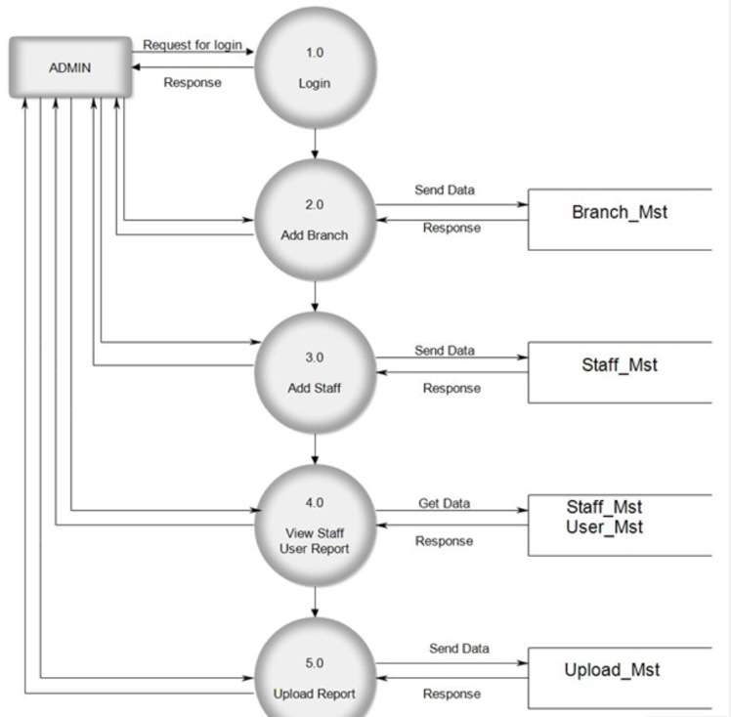

# CONCLUSION AND DISCUSSION

## Self-Analysis of Project Viabilities

It is cheaper to use our application for E-Learning because it is completely free.

## Problem Encountered and Possible Solutions:

**Scope Change:** It’s a mutual decision made by the team which involves adjustments to the scope, usage, timelines, other features of our applications as per the open-source software .

## Hardware Limitations

In the case of low or exhausted disk space, the issue is solved by extending the disk space and version controls are updated

# SUMMARY

In the development of our application, we first gathered the requirements of the project and decided the time schedule to meet the deadlines. We also design documentation for our project. After the project design, we focused on the project execution phase. To ensure proper project control and monitoring, we must monitor it to track/debug errors and glitches, calculate key performance indicators and track variations from allotted cost and time. We finally close the project by delivering the finished project to the customer.

# REFERENCES:

* + Wikipedia(2020) <https://en.wikipedia.org/wiki/Firebase>
  + Wikipedia(2020) <https://en.wikipedia.org/wiki/Agile>

[_software_development](https://en.wikipedia.org/wiki/Agile_software_development)

* + Wikipedia(2020)<https://en.wikipedia.org/wiki/Learning_Management_System>